|  |  |
| --- | --- |
| Canon EF 70-200mm f/2.8L IS III USM lens  Ống kính Canon EF 70-200mm f/2.8L IS III USM  Canon EF 70-200mm 3 Canon EF 70-200mm 1 Canon EF 70-200mm 2 Canon EF 70-200mm | **Featured information:**  Anti-vibration: Yes  Aperture: F/2.8-32  Closest focusing distance: 1.2m  Filter size: 77mm  Price: $ 1500  **Specifications:**  Focal distance  70 - 200mm  Largest Aperture  f/2.8  Smallest Aperture  f/32  Lens Mount  Canon EF  Lens Format  Full-Frame  View  34° - 12°  Minimum Focus Distance  1.2 m  Magnification  0.21x  Optical Components  23 lenses in 19 groups  Number of Mouth Blades  8  Focus Type  Auto focus |

**Overview:**

This EF mount telephoto lens is designed specifically for Canon Full-Frame format DSLR cameras. However, it can also be used with APS-C models and provides a 112-320mm equivalent focal length range.

Constant f/2.8 maximum aperture delivers consistent performance throughout the entire zoom range, for outstanding photography in low-light environments. At the same time, it increases control over depth of field, helping to isolate and highlight the subject from the background, very suitable for taking photos that require good background blur such as portraits, sports, etc.

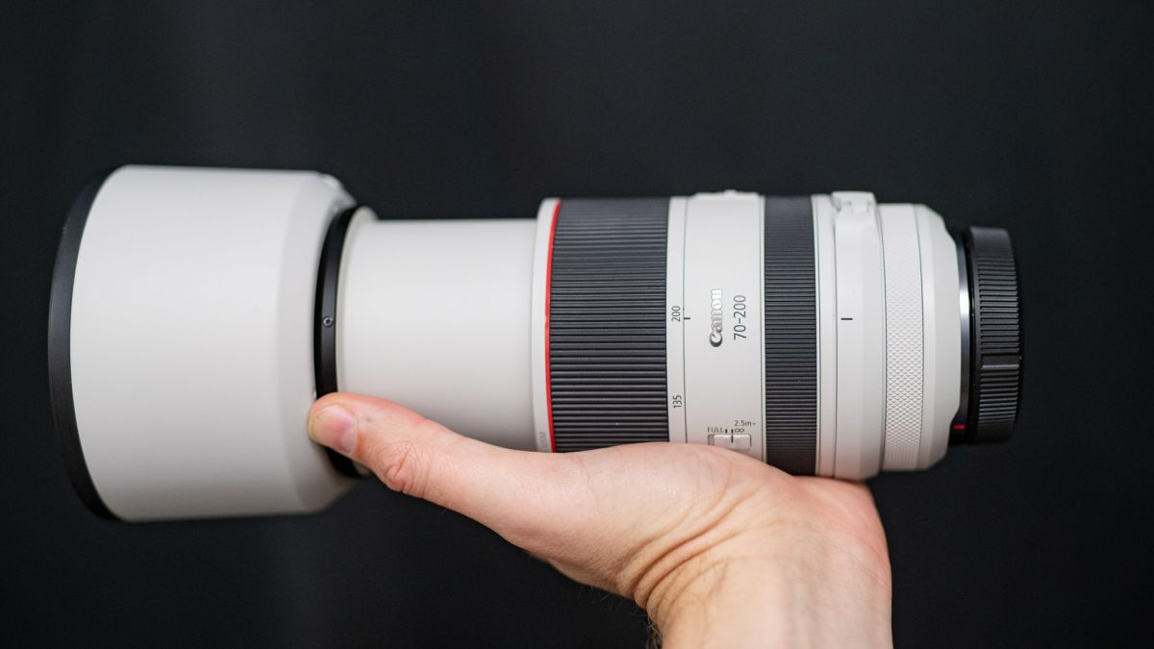

The lens is equipped with an Image Stabilization optical anti-shake system that provides effective anti-shake capabilities when shooting handheld. At the same time, increasing anti-shake ability up to 3.5 steps helps the lens work better in low light or low shutter speeds.

In addition, this anti-shake mechanism also allows reducing the shutter speed to 1/15s but still ensures maximum sharpness for the frame. This is an important function for close-up shots or users who have to frequently change shooting angles.

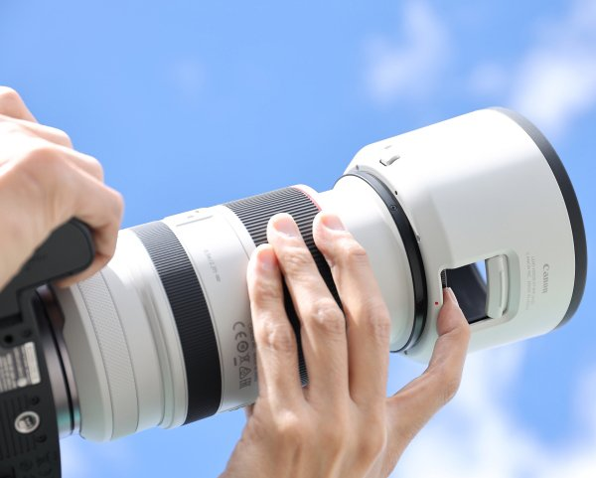

Belonging to Canon's high-end lens line - the L series with a distinctive red ring around the body, this telephoto lens is also weatherproof, dustproof and effectively prevents moisture from penetrating, protecting the lens for optimal operation. in different weather conditions.

In addition, Fluorine coating applied to the front and rear lenses helps limit fingerprints and smudges on the lens after use.

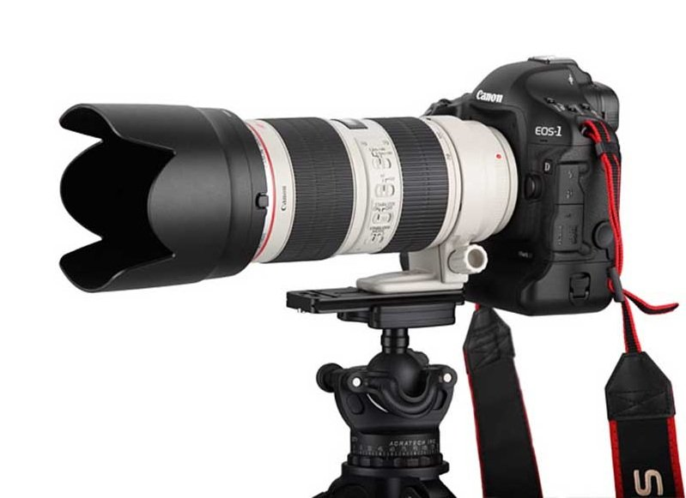

Besides, the lens is also compatible with EF 1.4X and EF 2X teleconverters, allowing users to zoom in for close-ups and zoom in on subjects at will while still ensuring sharpness in the frame.